**User Registration**

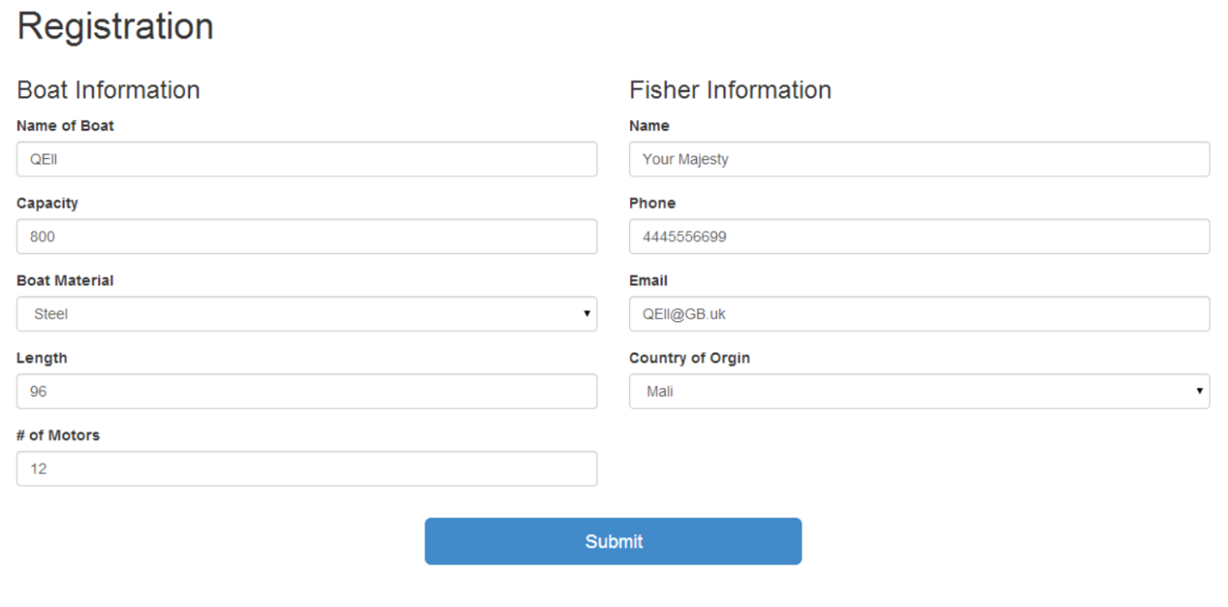<http://localhost:8080/register>

**User Home Page**

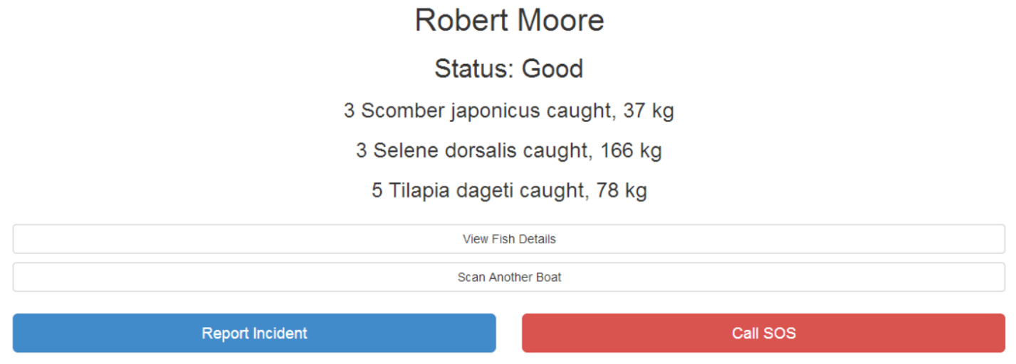<http://localhost:8080/>

**View Fish Details**

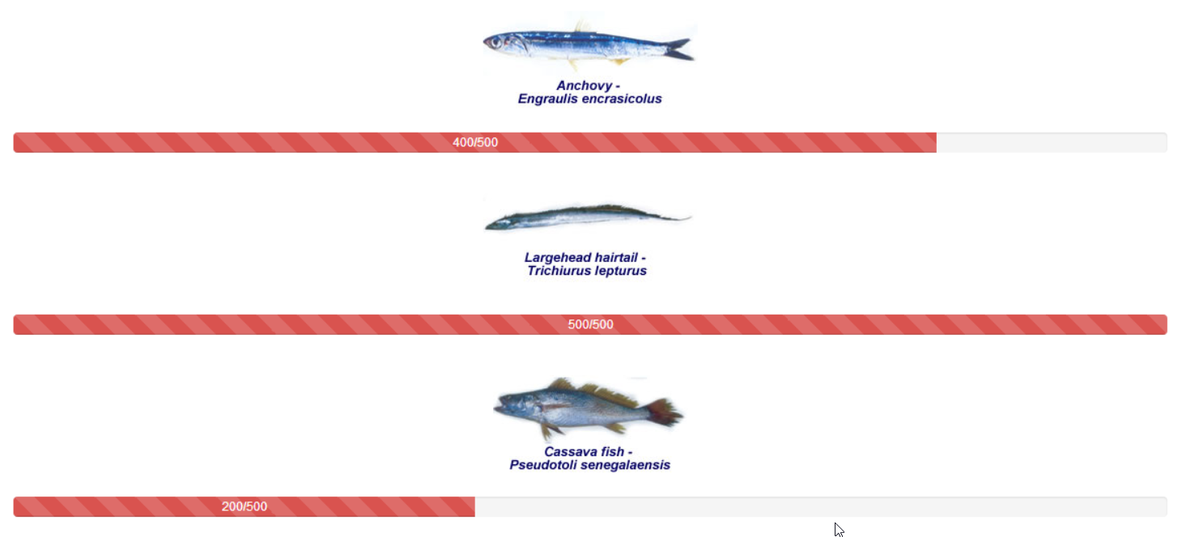<http://localhost:8080/fishquota>

**Report an Incident**

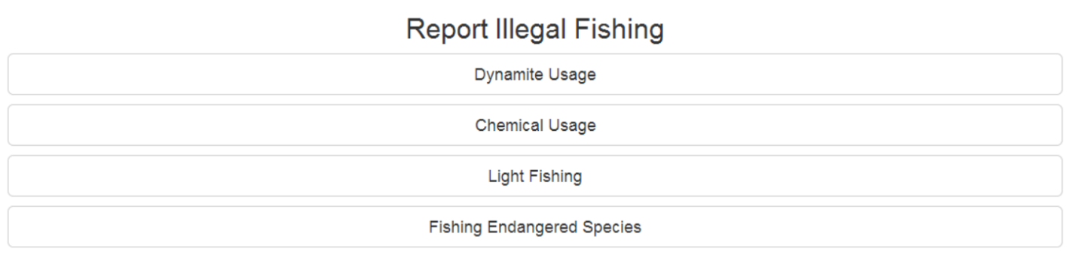<http://localhost:8080/report>

**Reporting Dashboard**

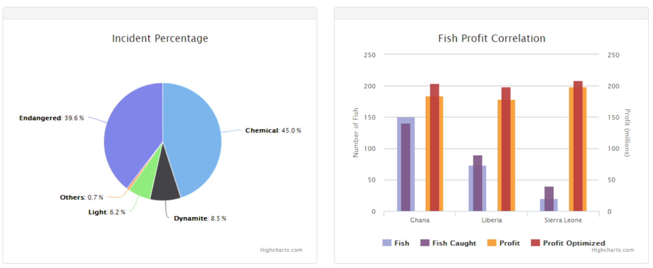<http://localhost:8080/dashboard.html>

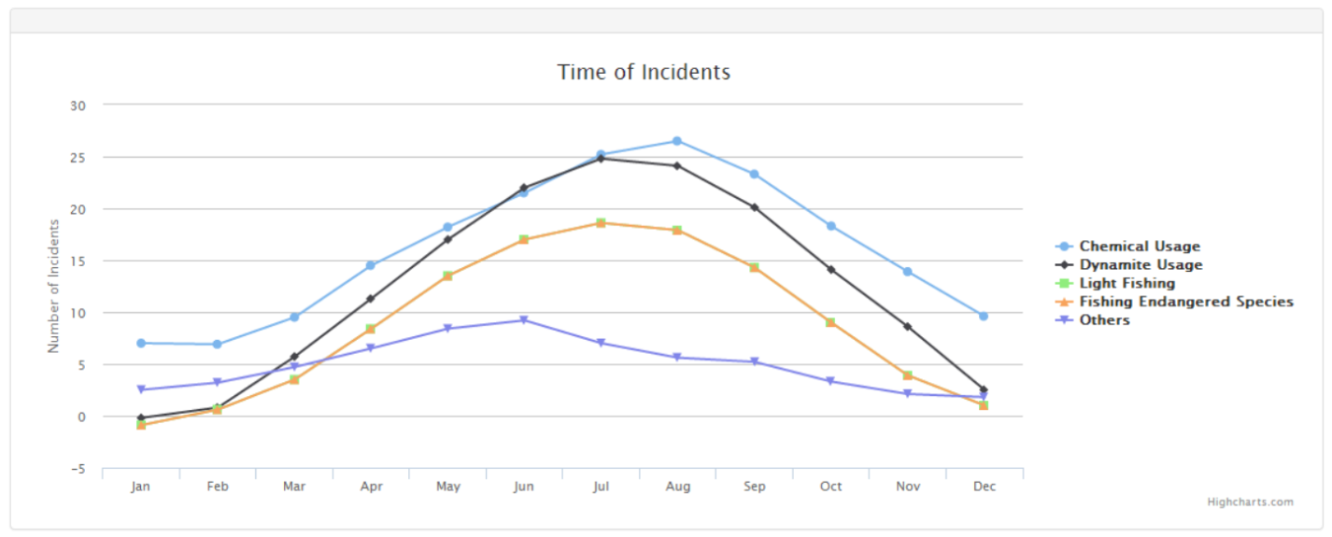

**General Information**

<http://localhost:8080/geninfo.html>

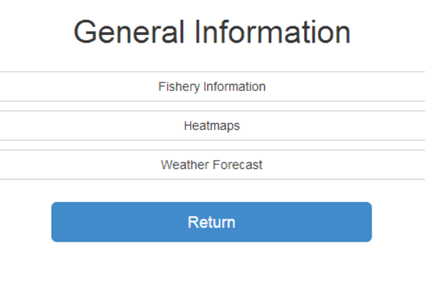

**Fishery Statistics**

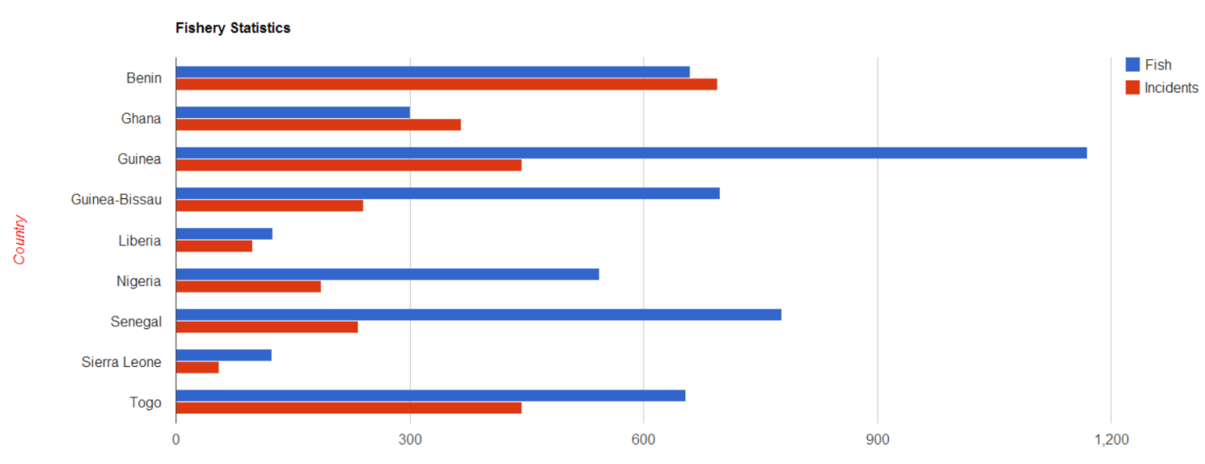<http://localhost:8080/bar_chart.html>

**HeatMaps**

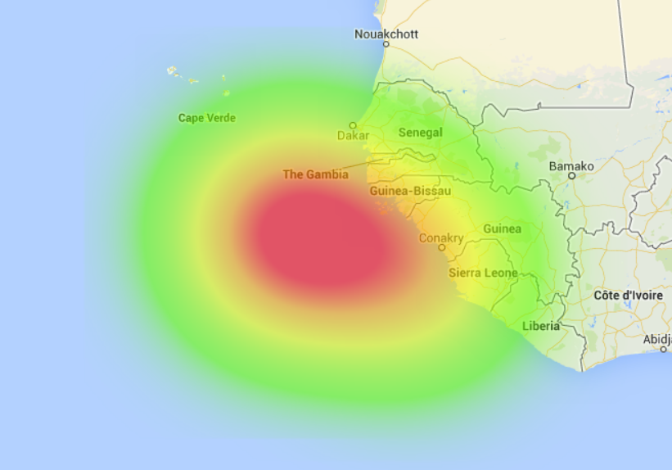<http://localhost:8080/heat_map.html>

**Weather**

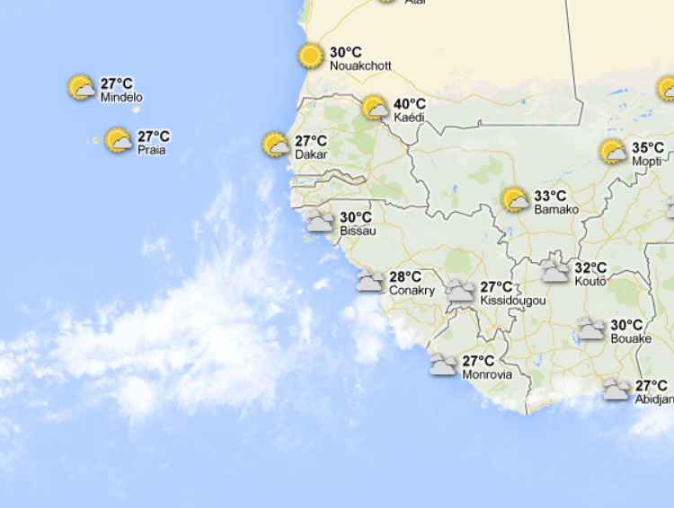<http://localhost:8080/weather.html>